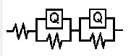
表1 拟合参数表
样品 | R_{s}  (Ω·cm²) | C_{f}*10⁶  (Ω⁻¹ cm⁻² s^{n}) | n_{f} | R_{f}  (kΩ·cm²) | Cdl*10⁶  (Ω⁻¹ cm⁻² s^{n}) | n_{d} | Rct  (kΩ·cm²) | Chi-  Squared
Pure Mo | 2.171 | 607.9 | 0.803 | 206.6 | 1117 | 0.507 | 8288 | 0.00741
Mo-Nb 20200601 | 2.575 | 139.1 | 0.778 | 93.32 | 92.11 | 0.696 | 3.982*10⁴ | 0.00865

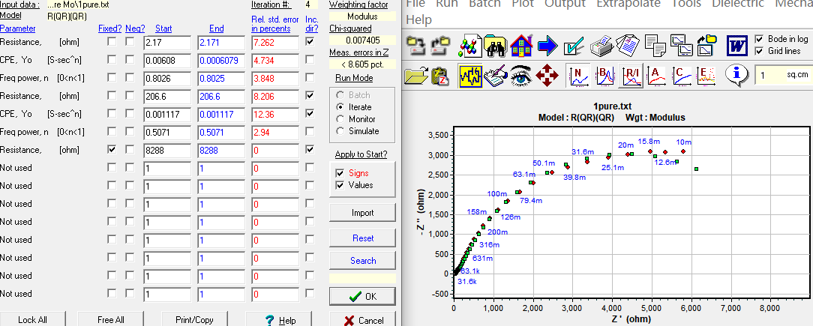
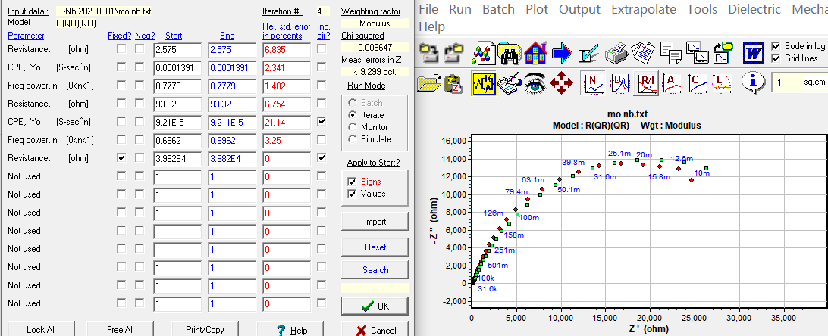

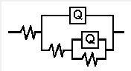
样品 | R_{s}  (Ω·cm²) | C_{f}*10⁶  (Ω⁻¹ cm⁻² s^{n}) | n_{f} | R_{f}  (kΩ·cm²) | Cdl*10⁶  (Ω⁻¹ cm⁻² s^{n}) | n_{d} | Rct  (kΩ·cm²) | Chi-  Squared
Pure Mo | 2.593 | 257 | 0.643 | 53.79 | 311 | 0.671 | 1.303*10⁴ | 0.0128
Mo-Nb 20200601 | 2.742 | 41.77 | 0.749 | 132.9 | 98.58 | 0.762 | 4.24*10⁴ | 0.0926

